OOP Assignment 3
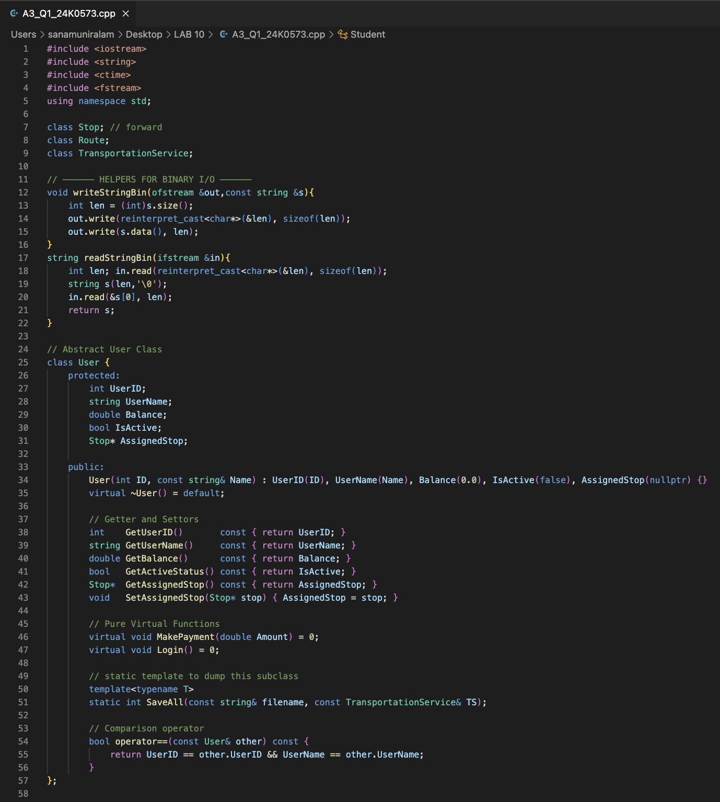
Q1 Code:

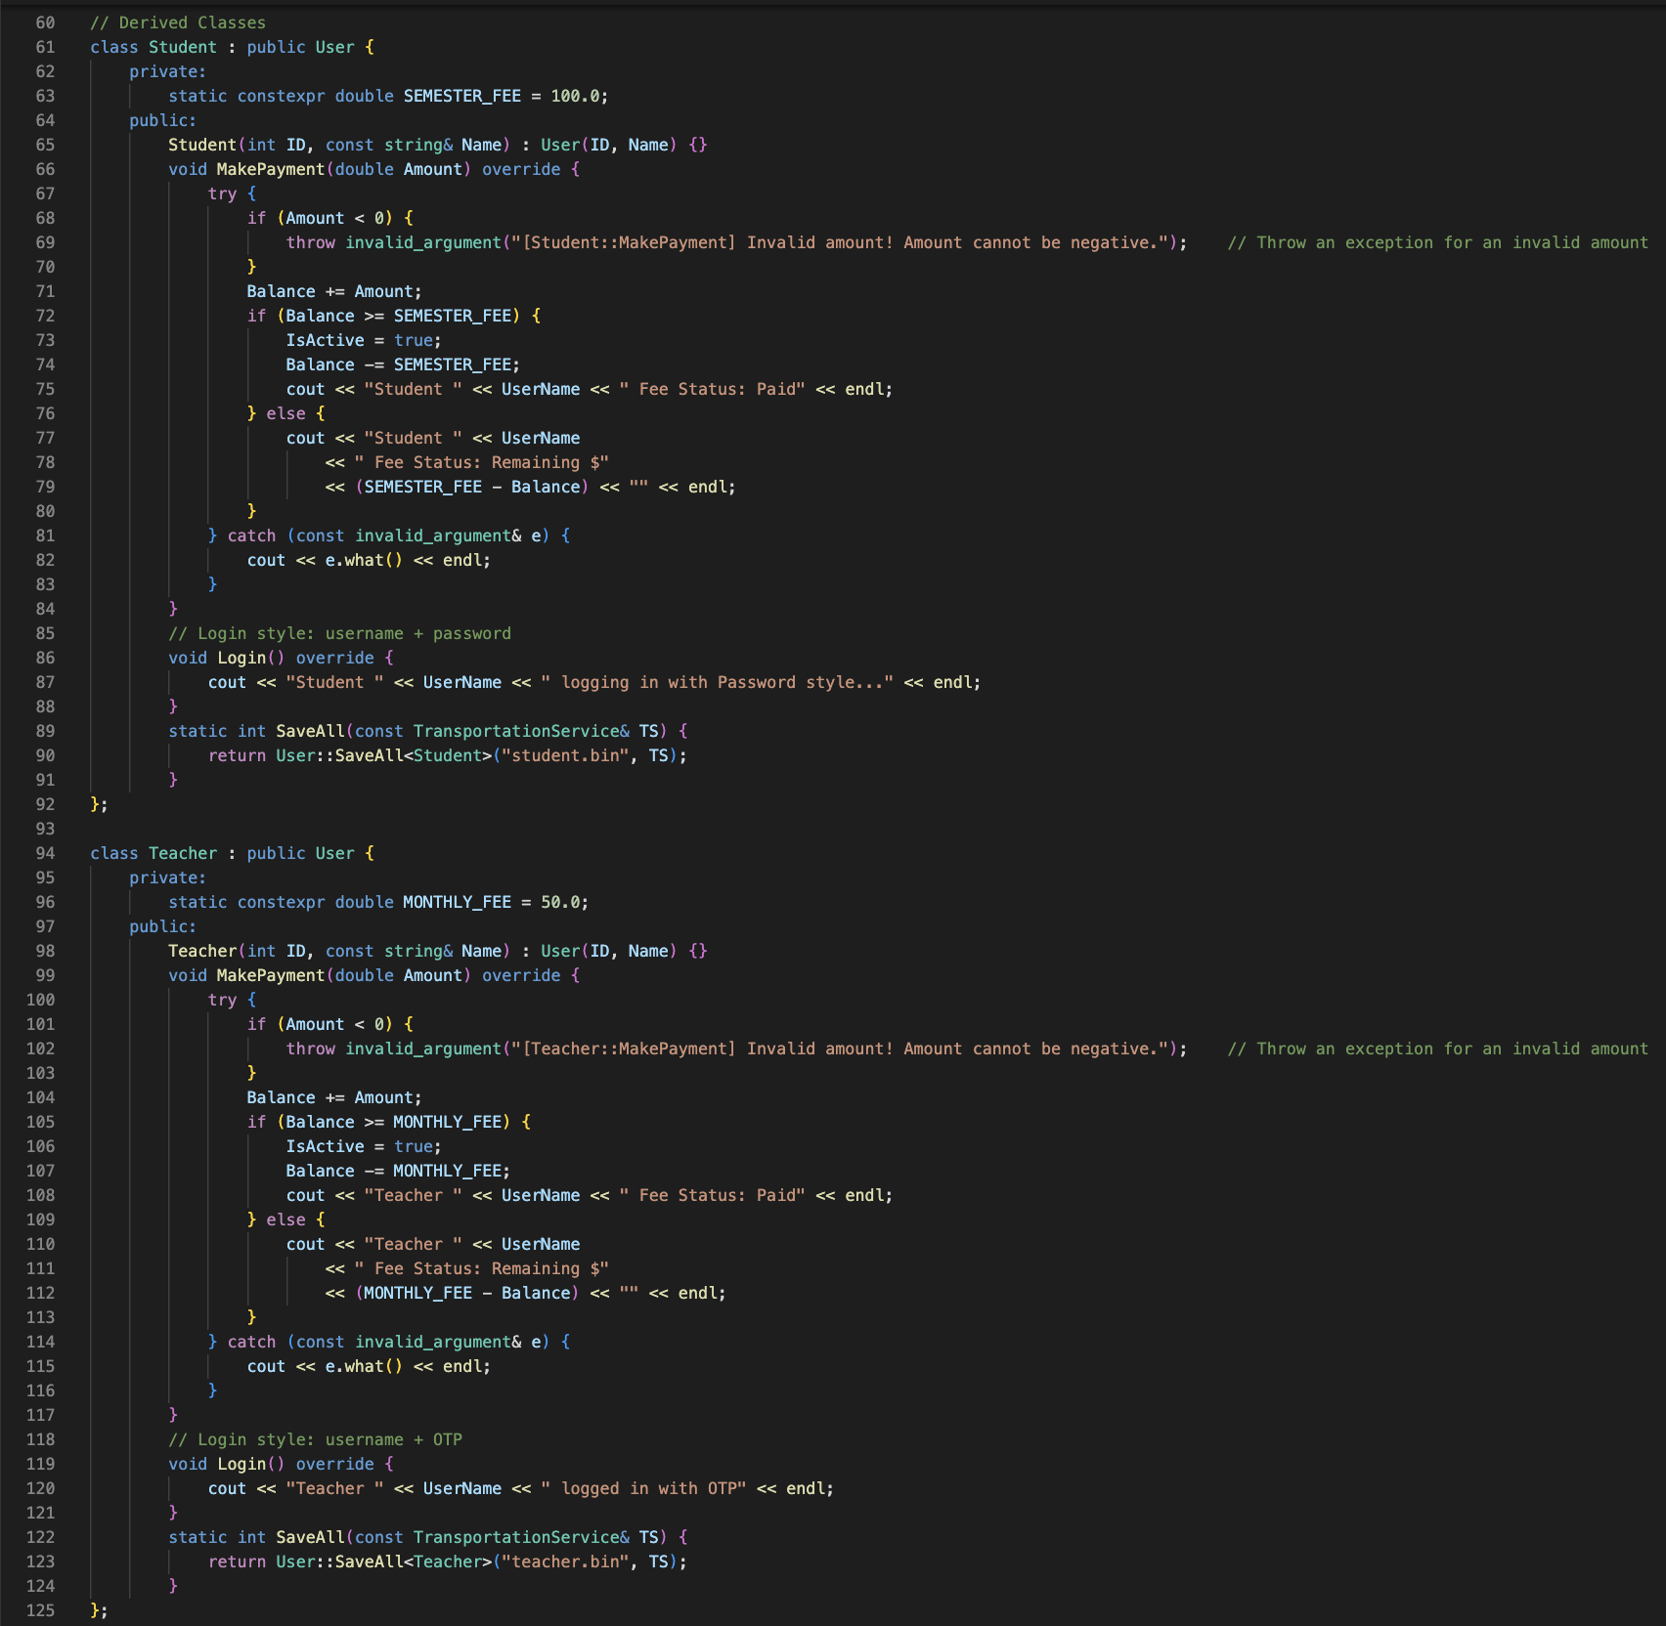
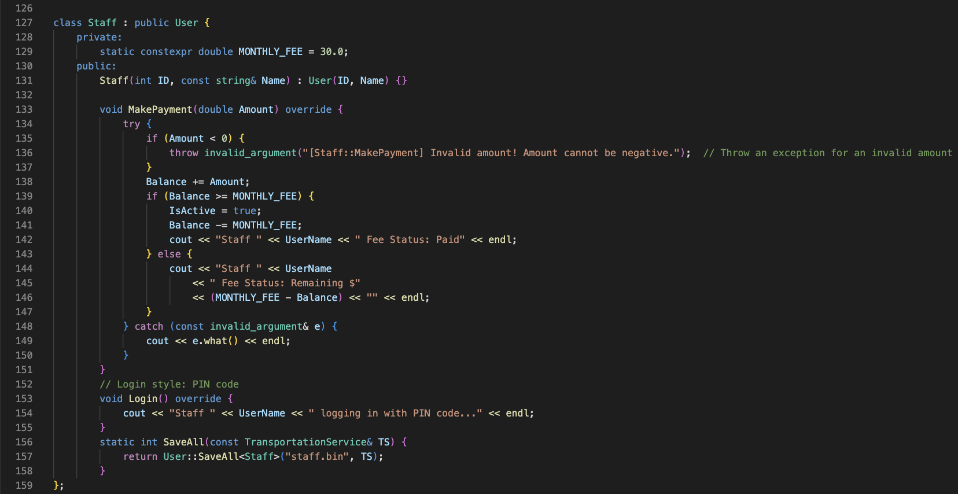

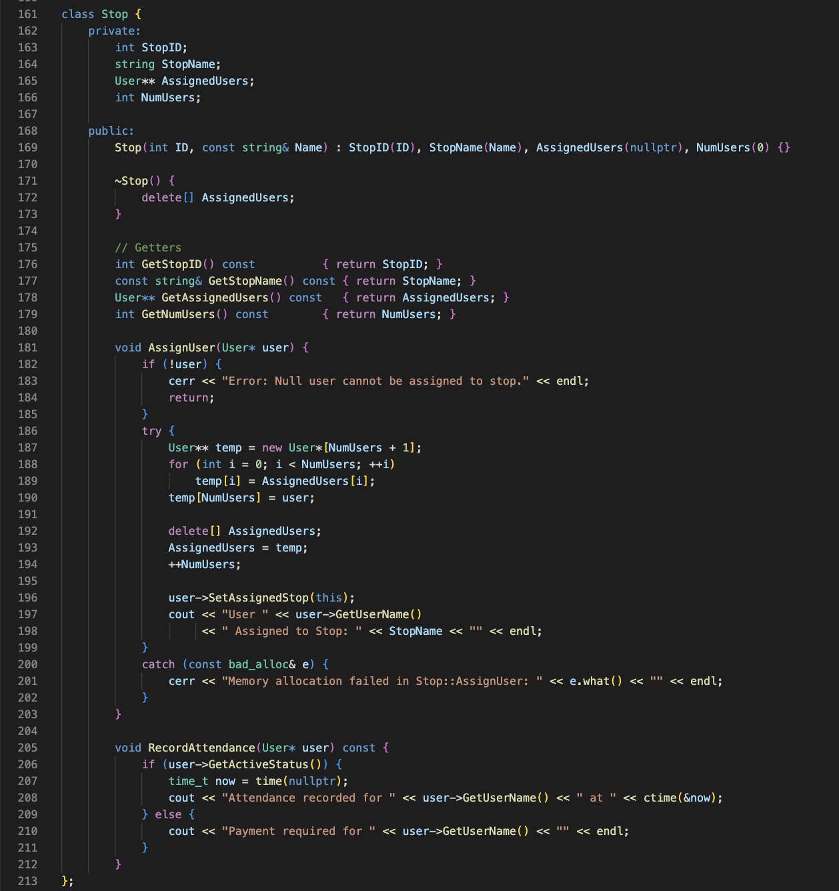

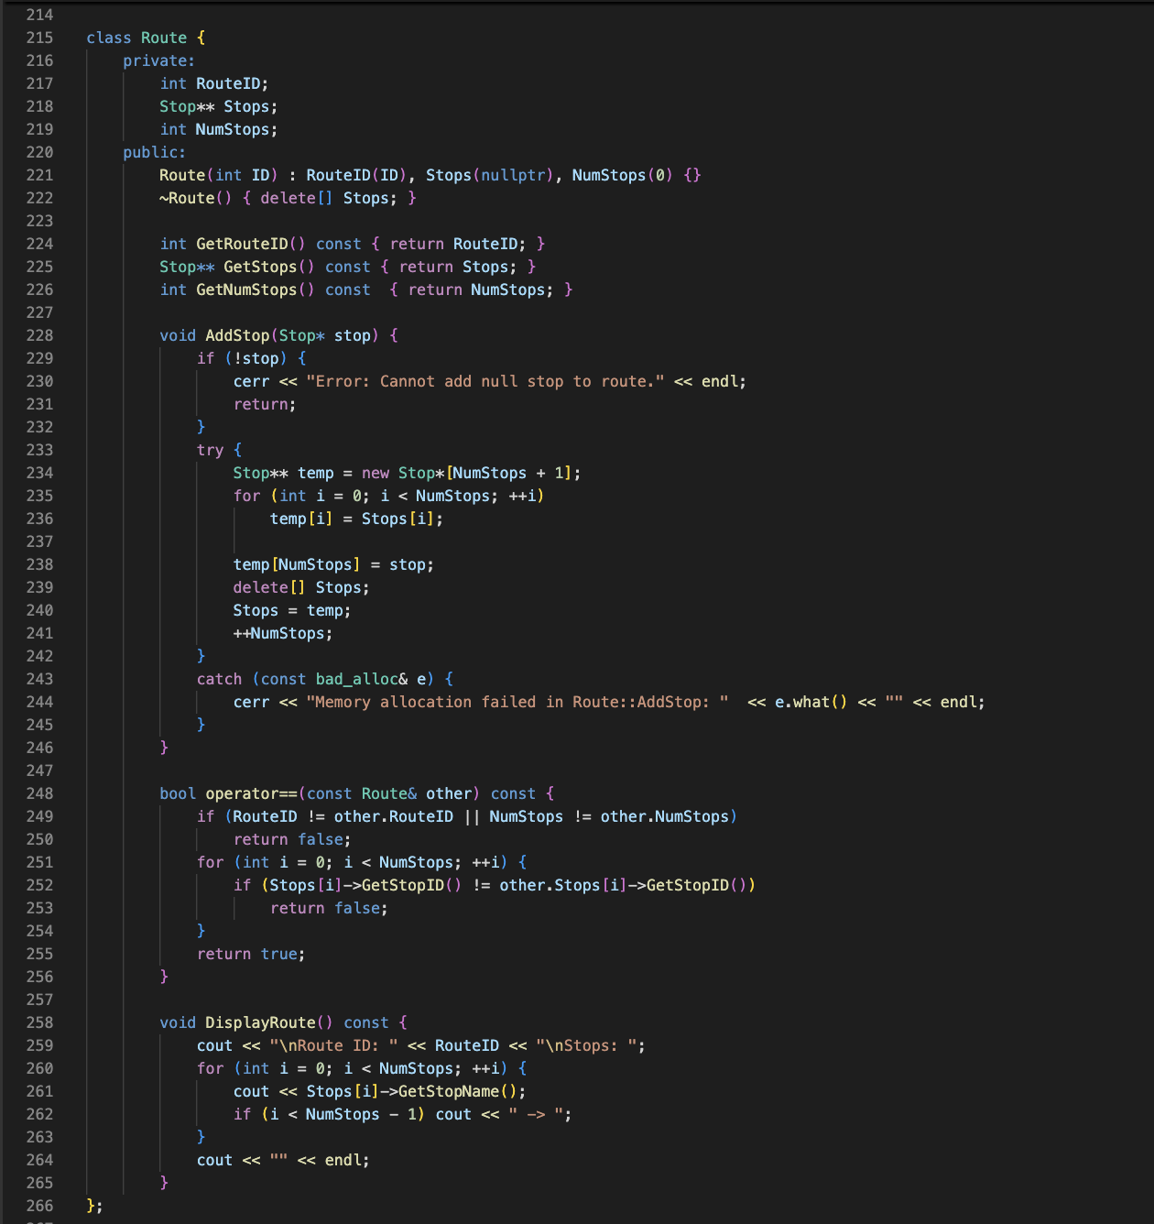

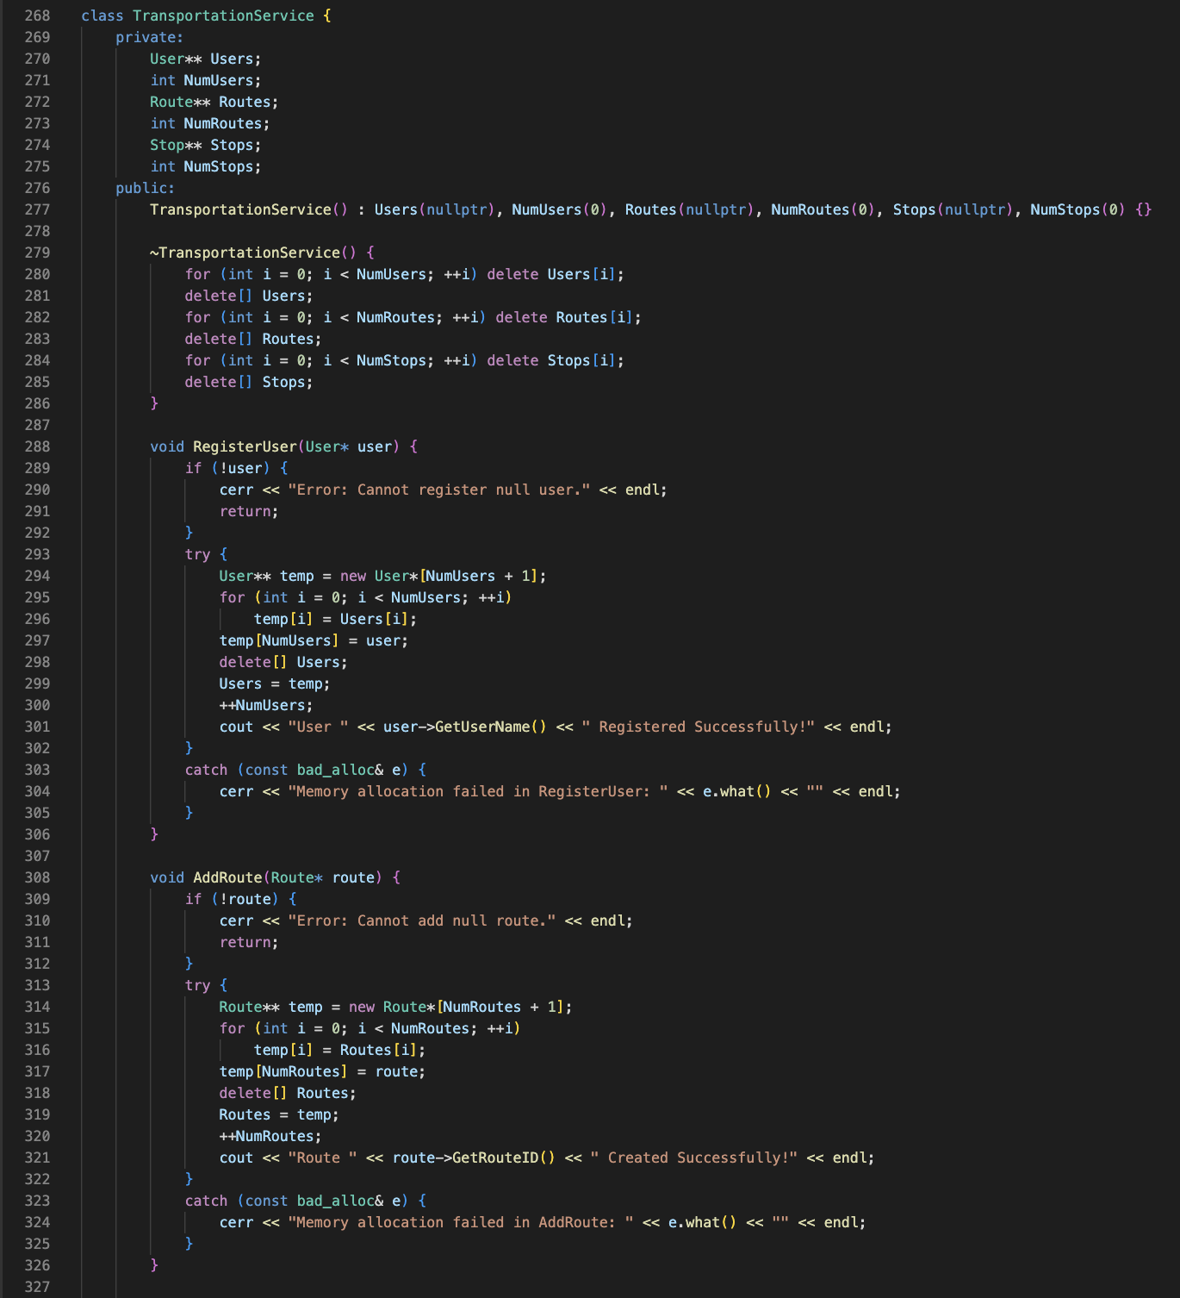
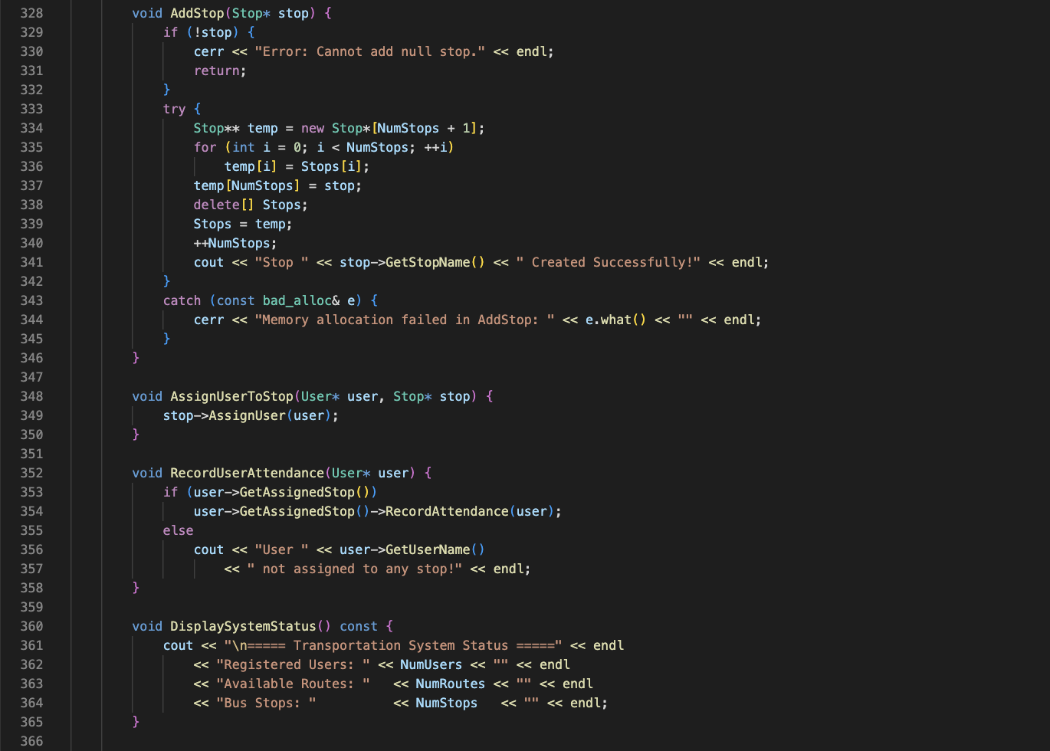

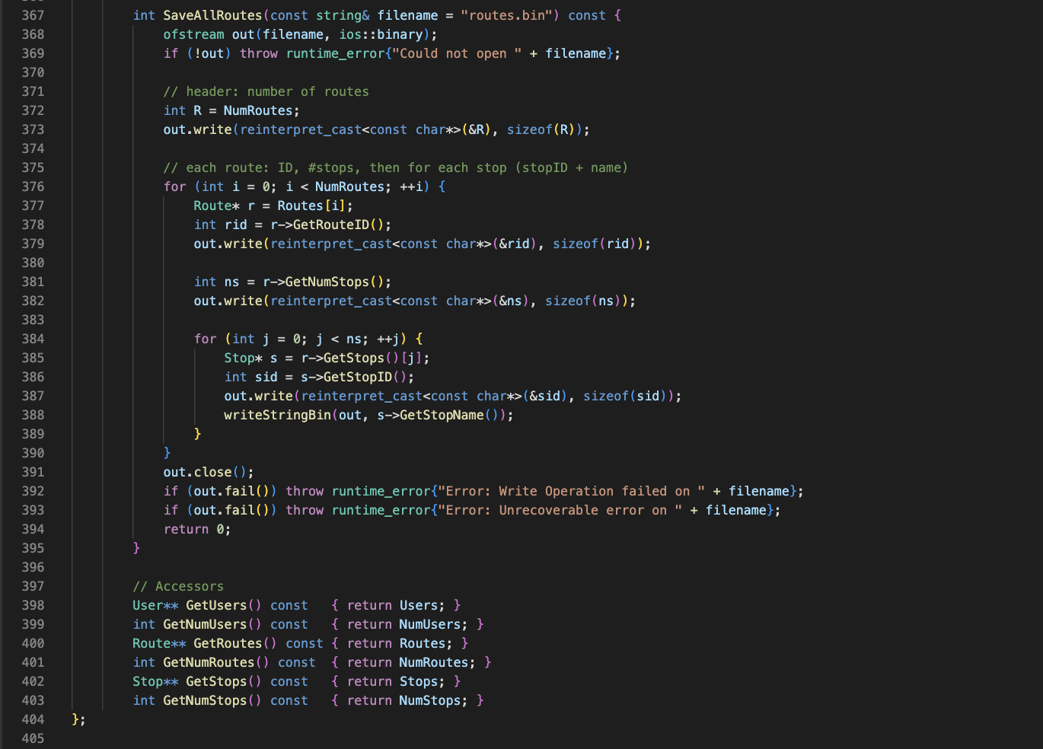
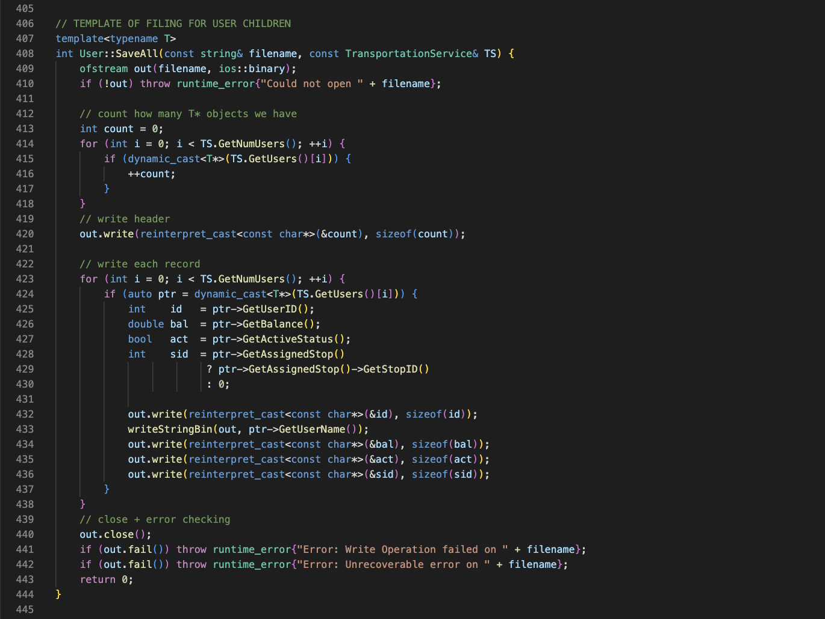

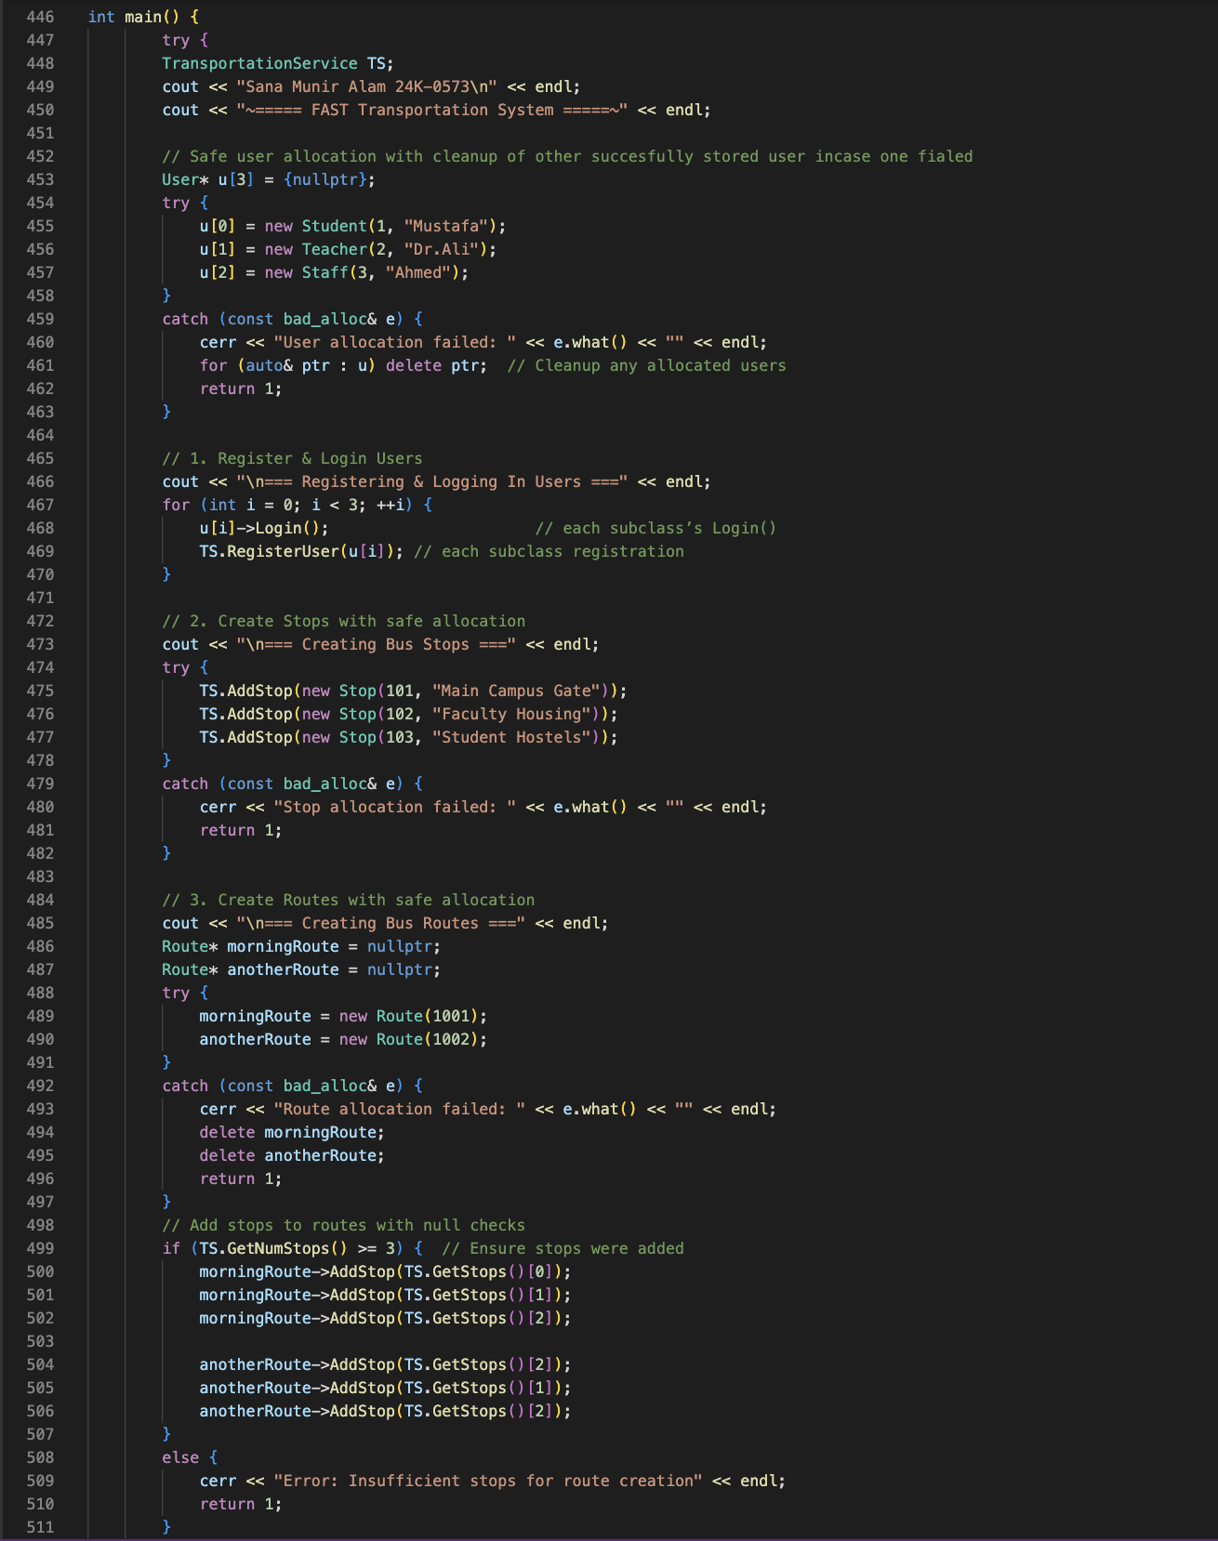

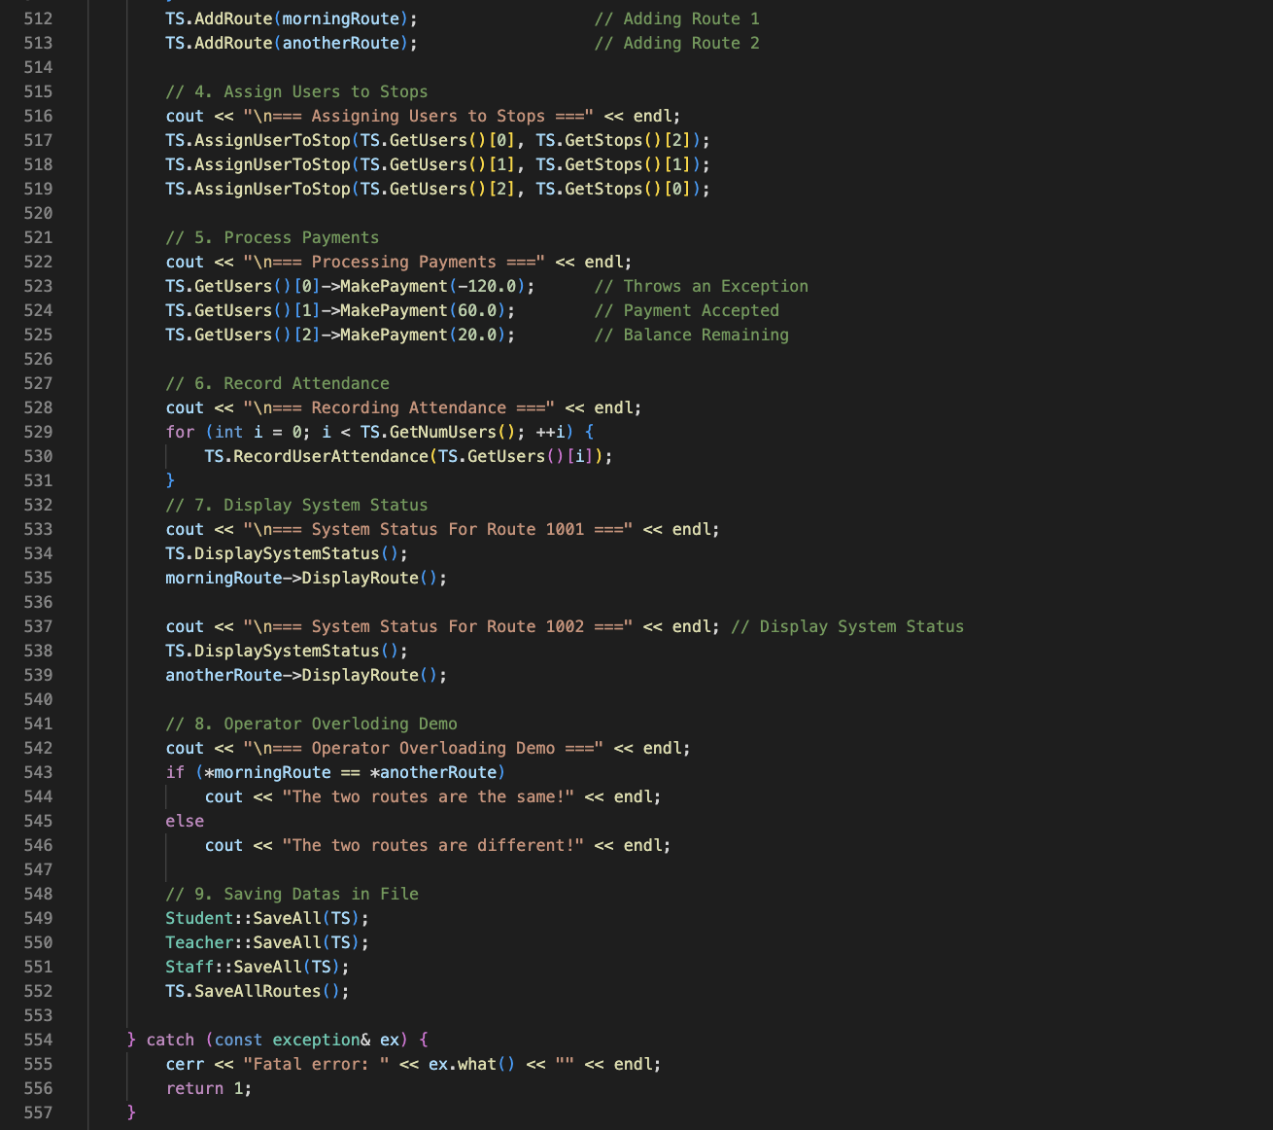
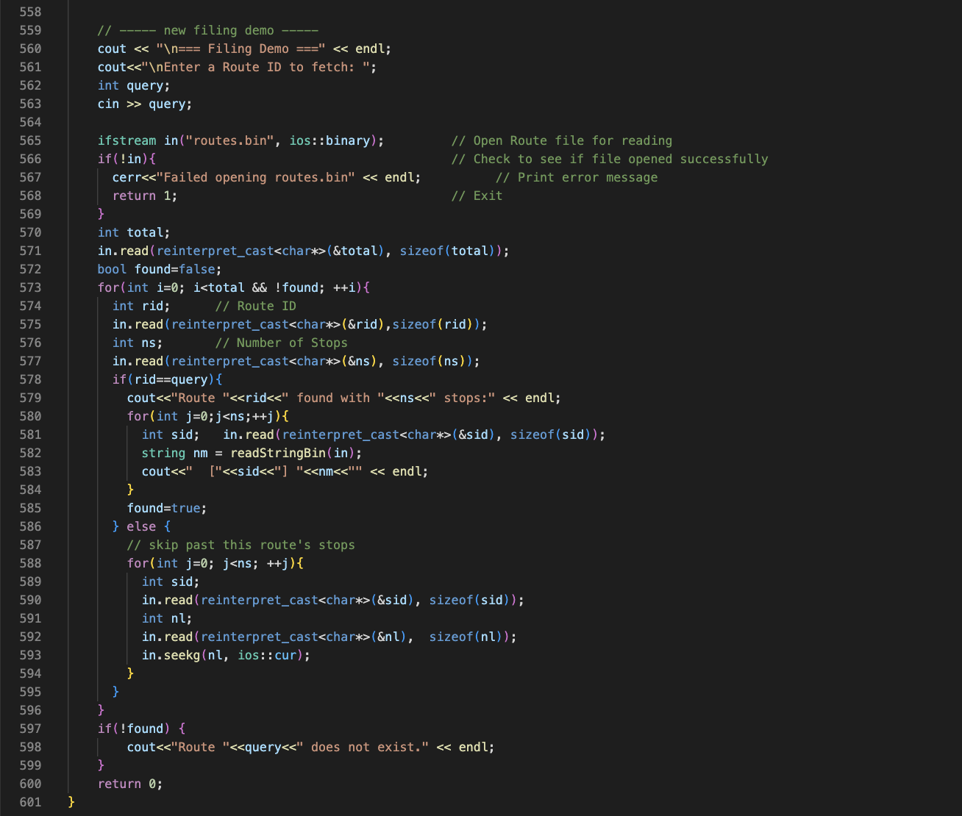

OUTPUT:
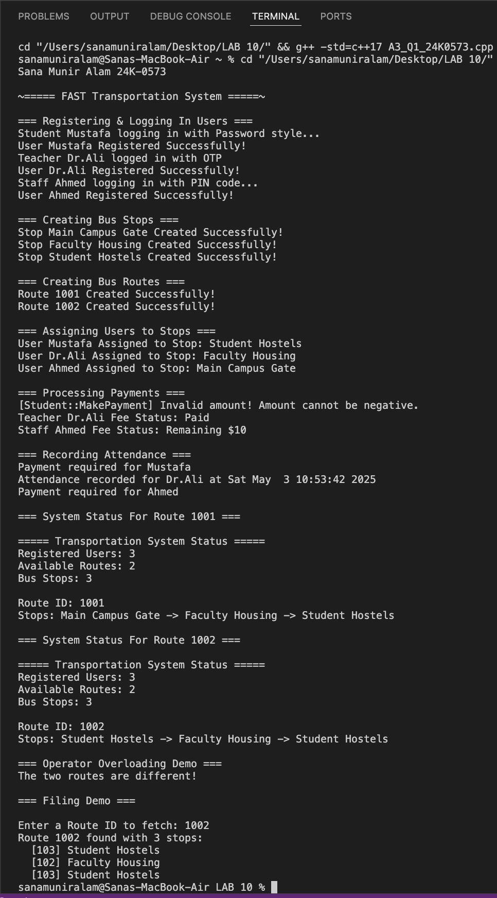

Demo of filing code working successfully in storing, reading and printing out the data
Exception Handling

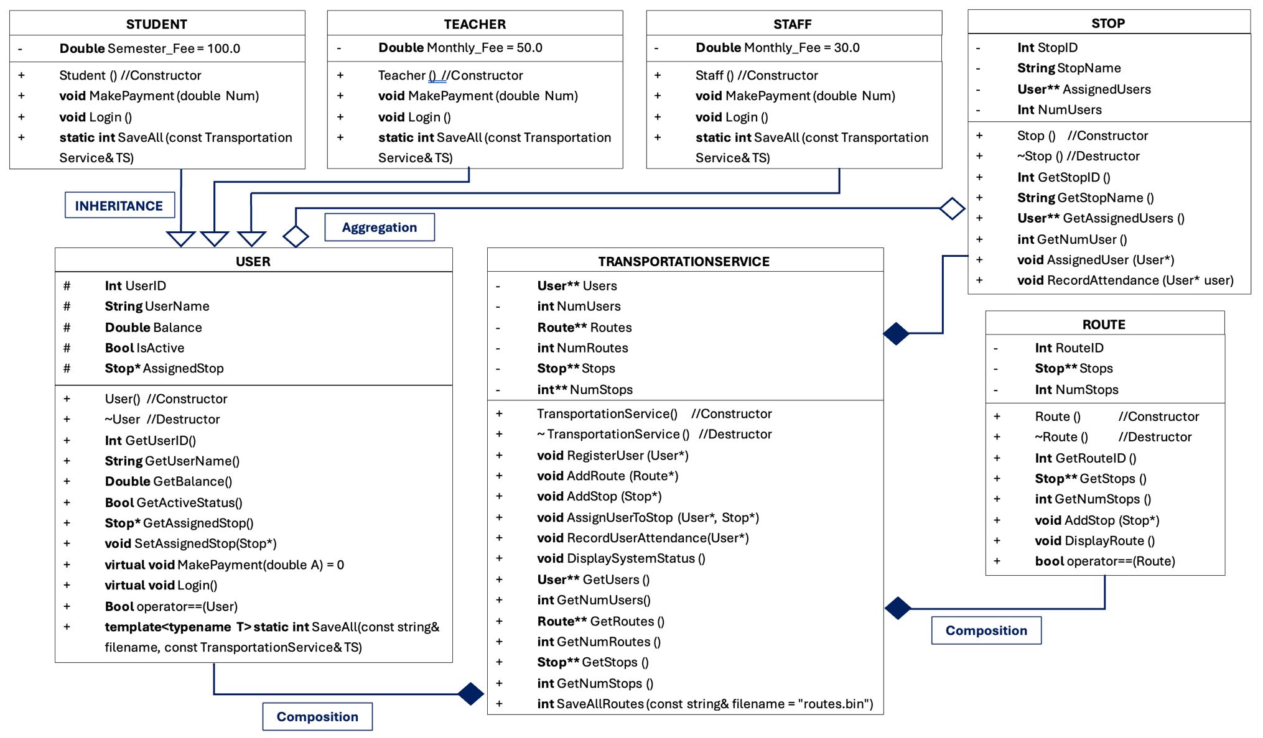

WALKTHROUGH:

FAST Transportation System — User Walkthrough

1. Starting the System
When the transportation system starts, users (Students, Teachers, and Staff) are automatically registered into the system. Each user sees a welcome message and is asked to log in based on their role:
- A Student logs in using a password.
- A Teacher logs in using an OTP (One-Time Password).
- A Staff member logs in using a PIN code.
Upon successful login, users are ready to use the transportation services.

2. Payment for Transportation
Before being able to use the bus service, users must make a payment:
- Students need to pay their semester transportation fee.
- Teachers pay a monthly fee.
- Staff members also pay a monthly fee, but a smaller amount compared to teachers.
The system guides users to complete their payments. It also shows how much is paid and whether any balance remains. An error is shown if invalid amount is entered.
Once full payment is made, the user’s transport account becomes active.

3. Being Assigned to a Bus Stop
After activation, users are assigned a specific bus stop depending on their needs:
- A Student might be assigned to the "Student Hostels" stop.
- A Teacher might be assigned to the "Faculty Housing" stop.
- A Staff member might be assigned to the "Main Campus Gate" stop.
Users receive a notification telling them which bus stop they are assigned to. Now they are part of the daily transportation routes.

4. Attendance at the Bus Stop
When users arrive at their assigned bus stop, the system records their attendance.
If a user's account is active (i.e., payment has been completed), their attendance is marked successfully with a timestamp.
If the account is inactive (payment not completed), the system informs the user that they need to complete their fee payment before they can use the transportation service.

5. Viewing Transportation Routes
Users have access to information about the transportation routes available:
- They can view which bus stops are included in a particular route.
- They can fetch information about a specific route by entering the Route ID (e.g., 1001 or 1002).
- The system displays all the stops in that route along with their names and stop IDs.
This helps users understand the full route of the bus they are assigned to.

6. System Summary
At any time, users can see a summary of the transportation system, including:
- Total number of registered users.
- Number of available bus routes.
- Number of bus stops in the system.

7. System Ending
Once the user’s daily interaction is done — payments made, attendance recorded, and routes viewed — the system saves important information (such as user data and route information) into secure files, ensuring the data is available the next time the system is used.

